Name: Looi Kah Fung

Matric no: P-COM0049/22

Date: 28th Nov 2022

Course: Lab 5 CDS502 Principles & Practices of Data Science and Analytics

1.



1 standard deviation = 33.33%

2 standard deviations = 68%

3 standard deviations = 99.99%

Assumption >50% of the students resides in the range of 55% and 75%, averagely the mean 65%. The std would be 10% (75%-55%)/2.

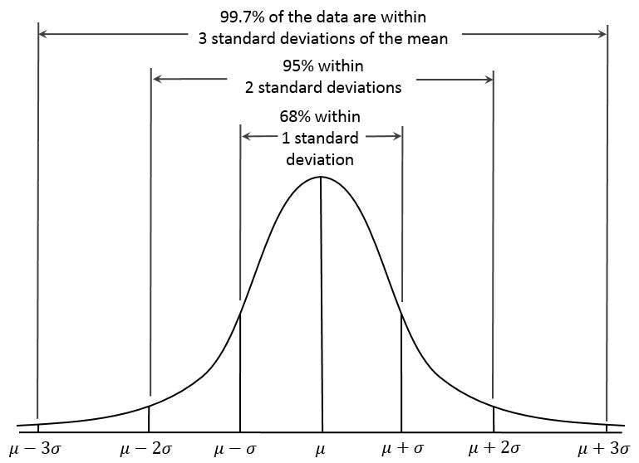

2.

3.

